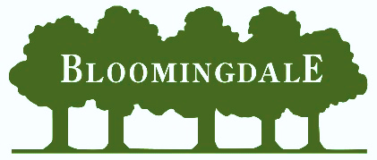

Bloomingdale Neighborhood Association Inc.

PO Box 6313 Brandon, FL 33508

Phone: 813-681-2051

Email: bl.neighbor1@gmail.com

Website: www.Bloomingdale.Life
Facebook: @Bl.Neighbor1

You are invited to join the BNA in 2025!

Hi neighbors! We want to invite you to be part of the Bloomingdale Neighborhood Association (BNA). The association works to make our neighborhoods a great place to live by offering services that address resident concerns and providing gatherings to promote community. Our BNA promotes neighborhood cohesion and harmony while protecting our property values. The BNA is a 501 (c)(4) non-profit organization. Your participation is voluntary and significant. It makes a tremendous difference.

What does the BNA do for your neighborhood and what does your membership support?
- Provides a variety of ways to share community information through The Bloomingdale Gazette, social media platforms and the office manager.
- Advocates at government meetings to address quality-of-life issues affecting our community, including land use, transportation, safety, and security matters.
- Organizes and sponsors annual neighborhood events including the Clean-up Day 2/4/23, Bunny Visit 4/2/23, the Music Bingo at Bullfrog Creek Brewery to benefit The Seeds of Hope Food Bank 8/3/23, Bloomingdale Community Garage Sale 9/9/23, and Santa Visit 12/3/23.
- Partners with local schools by providing opportunities for community service hours, scholarship opportunities, and youth improvement/education programs. Read about our scholarship program on the reverse side of this letter.
- Manages a neighborhood standards program based on county codes to help retain our neighborhood beauty and keep the community a wonderful place to live, work, and call home.
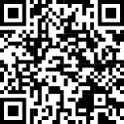
You are welcome to attend our monthly board meetings at 7 p.m. on the second Tuesday of each month. All meeting and event information is on our website www.Bloomingdale.Life.

Please return your $35 membership dues and membership card in the enclosed envelope or use the PayPal option by scanning the QR code or visiting our website. The QR Code will offer 3 options: Dues only, Scholarship only and Dues and Scholarship combined.

Bloomingdale is a beautiful community. Join today as every resident and every dollar matter. We thank you for your support.
Sincerely,
The Board of Directors, Bloomingdale Neighborhood Association, Serving Bloomingdale Since 1979
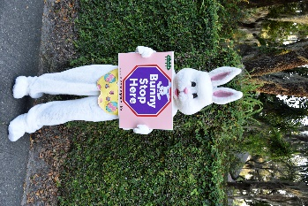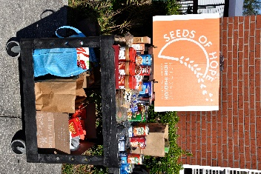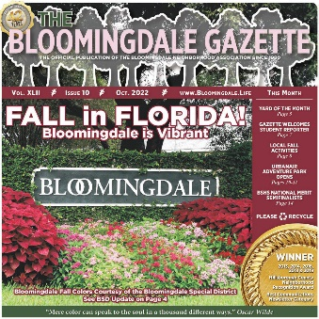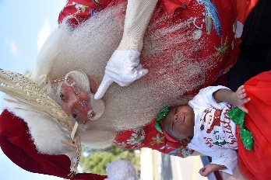

Bloomingdale Neighborhood Association
2025 B.J. Stelter Community Scholarship
Donation Request

Help a Deserving High School Senior!

Make a scholarship donation by sending your check made payable to the Bloomingdale Neighborhood Association Scholarship or BNAS. Donations can also be made through our website via PayPal, visit bloomingdale.life, look for the PayPal link.

This scholarship was named in honor of former Bloomingdale High School principal B.J. Stelter in 2006. She served our community children for 16 years. By donating to this worthy program, you are honoring her legacy and recognizing a deserving young person. Your donation is an investment in, not only, the winner’s future, but also the future of our community.

The 2022 winner was BSHS senior Ryan Marquis who attends UCF in part because of your generous donations to last year’s funds.

All high school seniors residing in our community whose families are members of the BNA are eligible to apply for this scholarship. They do not need to attend Bloomingdale High School to qualify. The deadline is April 4, 2025, for this coming year. Application and other information are available online at www.Bloomingdale.Life.

Thank you for supporting our community and our youth!

Sincerely,
The Board of Directors
Bloomingdale Neighborhood Association

- - - - - - - - - - - - - - - Cut Here - - - - - - - - - - - - - - - - -

Return This Form with your Donation
Bloomingdale Neighborhood Association
2025 B.J. Stelter Community Scholarship
Make checks payable to Bloomingdale Neighborhood Association Scholarship or BNAS

Name: ____________________________________ Donation Amount: $________________
Address: __________________________________________ Check No: _______________
City: ______________________________ State: ___________ Zip: _________________

Please include this stub with your check. For your convenience, you may include your scholarship donations with your 2023 BNA $35 membership in one check. The Bloomingdale Neighborhood Association Inc. is an IRC 501(c)(4) organization.

